# CS 255 System Design Document

Cory Remick

8/13/2022

## UML Diagrams

### UML Use Case Diagram

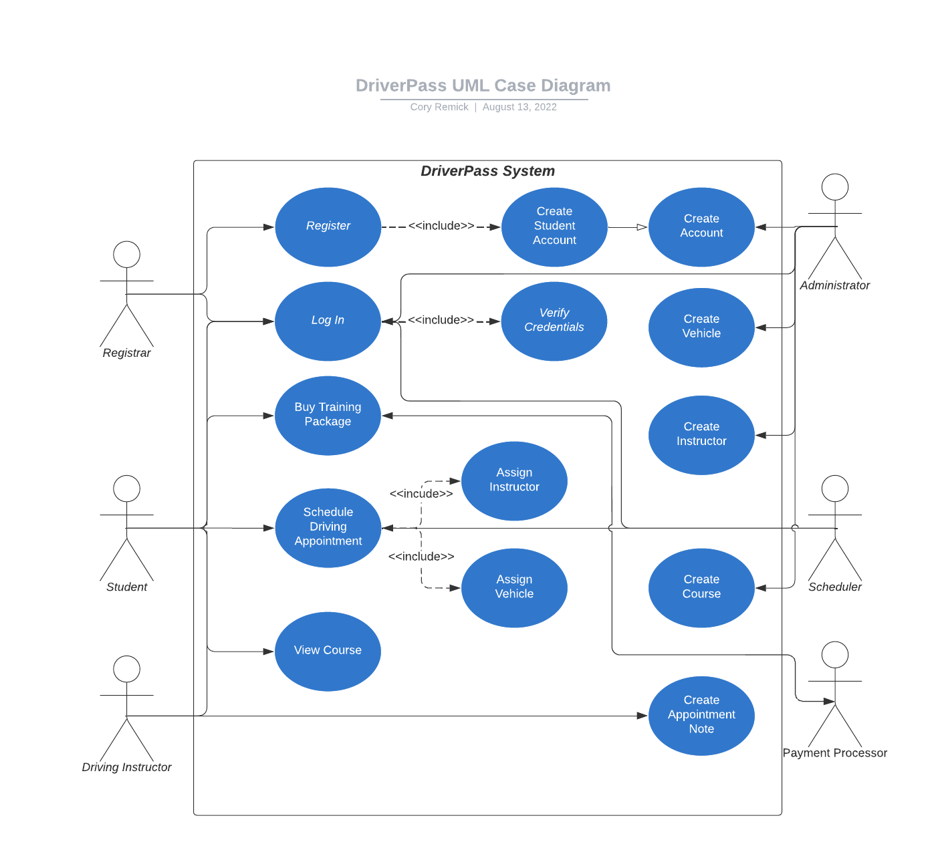

Figure Use Case Diagram

### UML Activity Diagrams

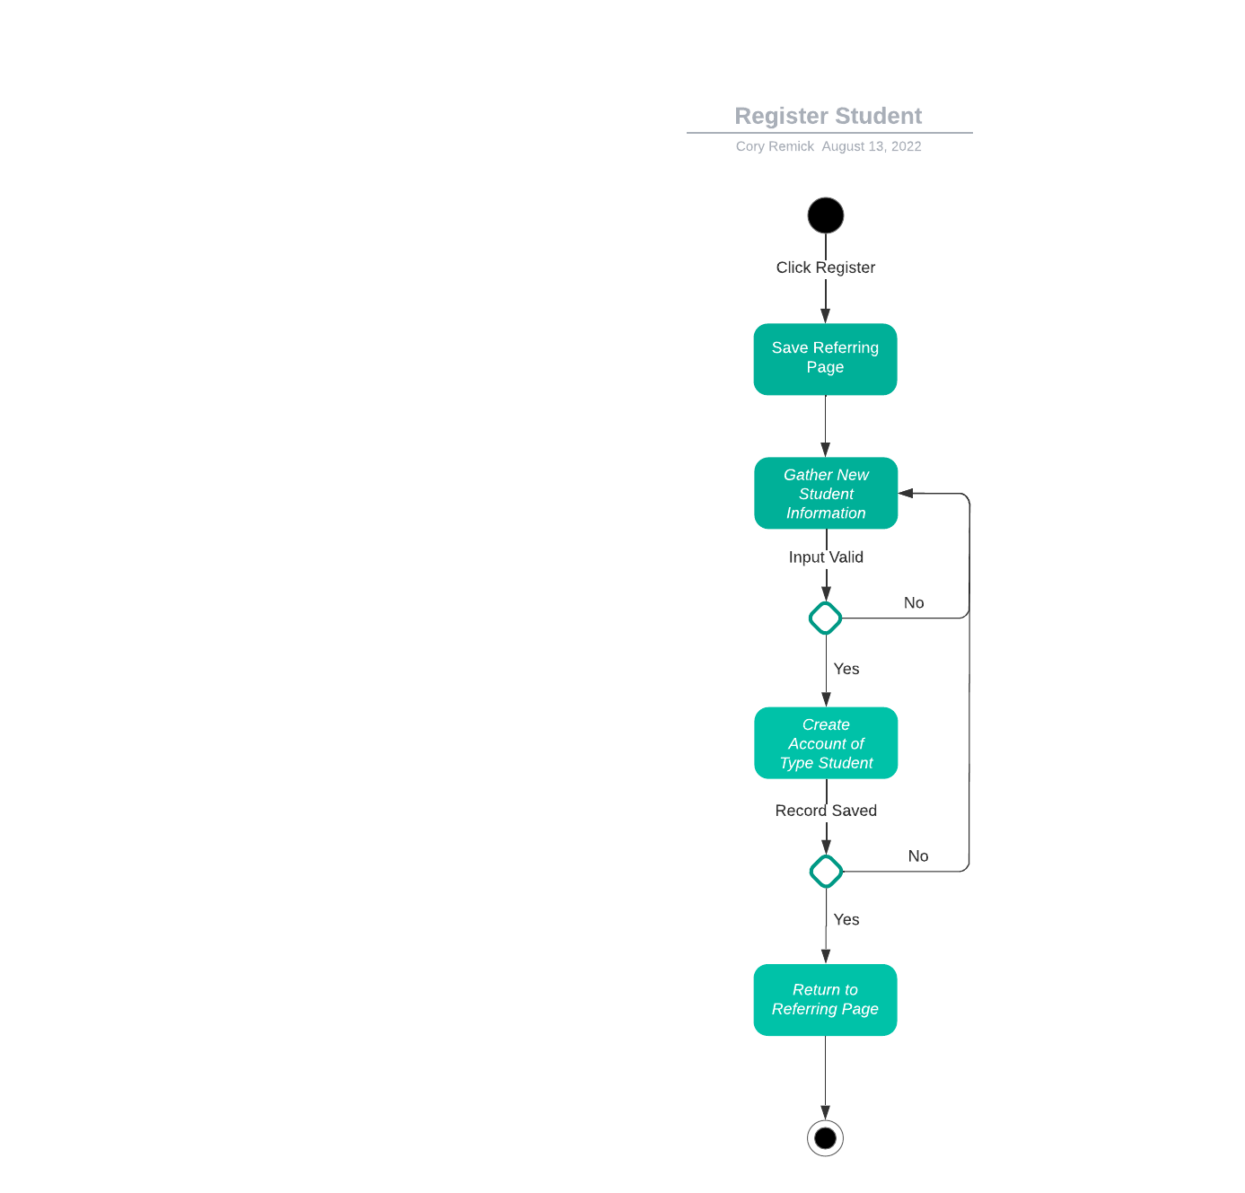

Figure Register Student

Figure Schedule Driving Appointment

### UML Sequence Diagram

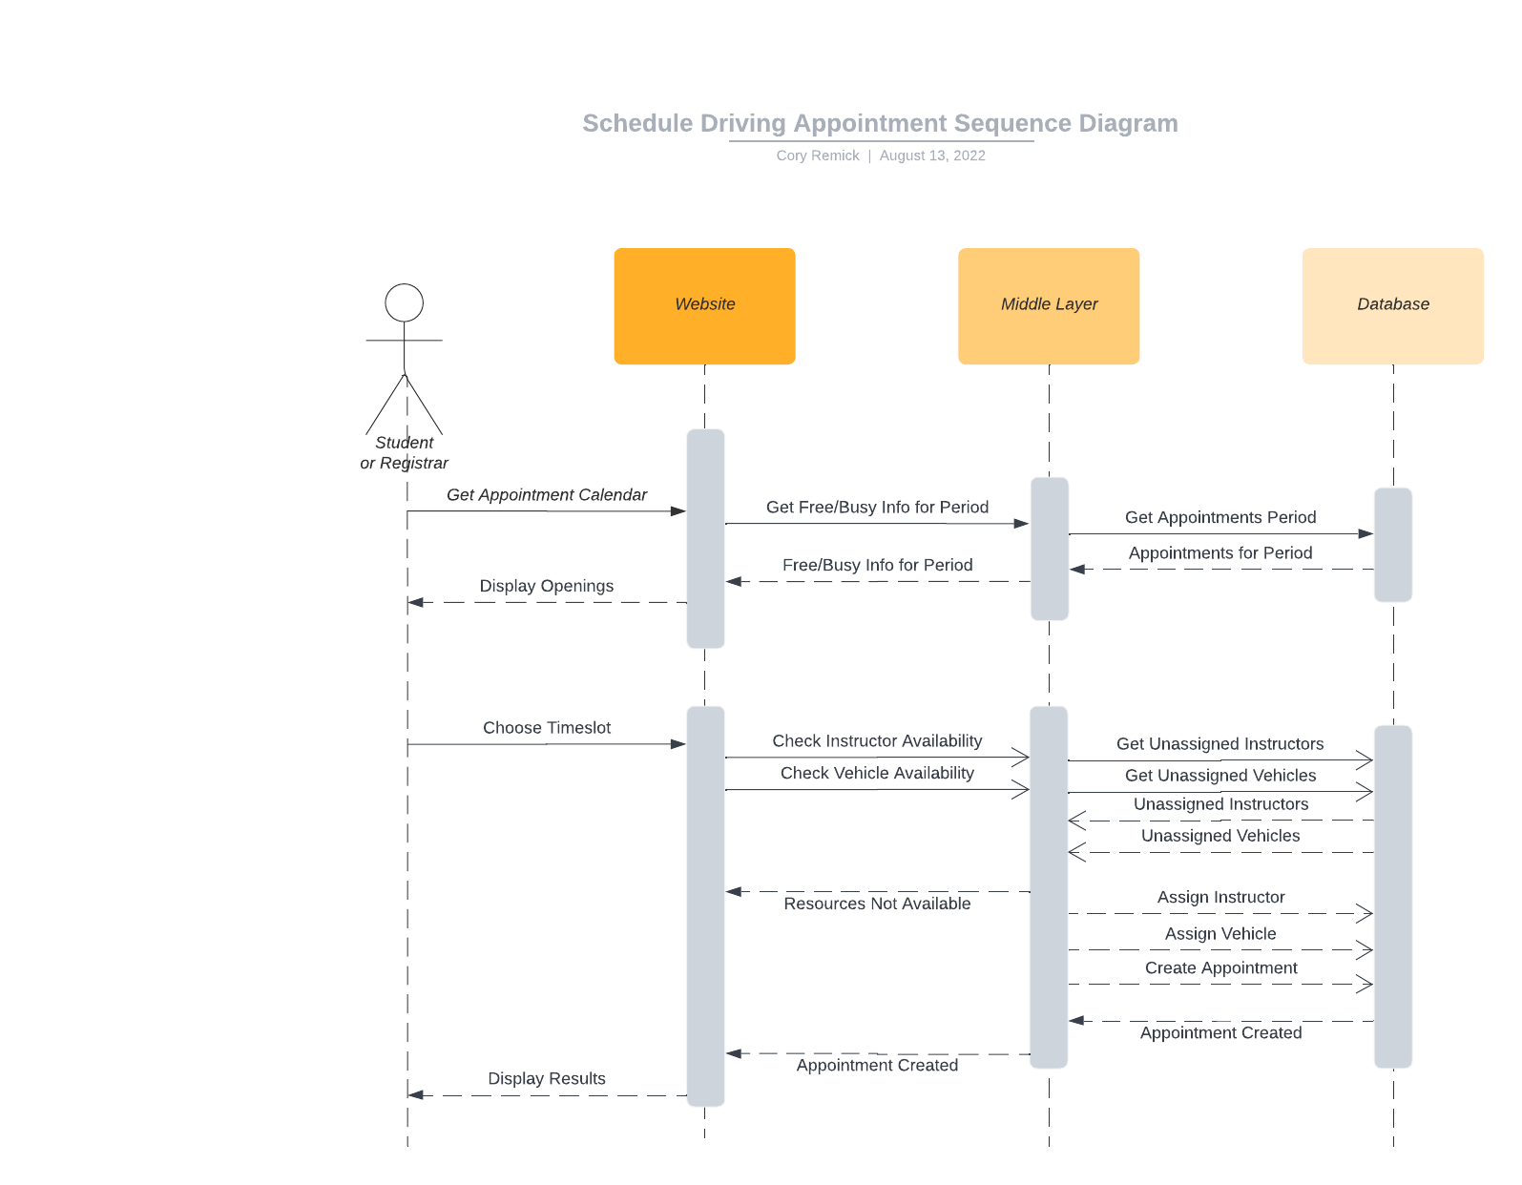

Figure Sequence Diagram

### UML Class Diagram

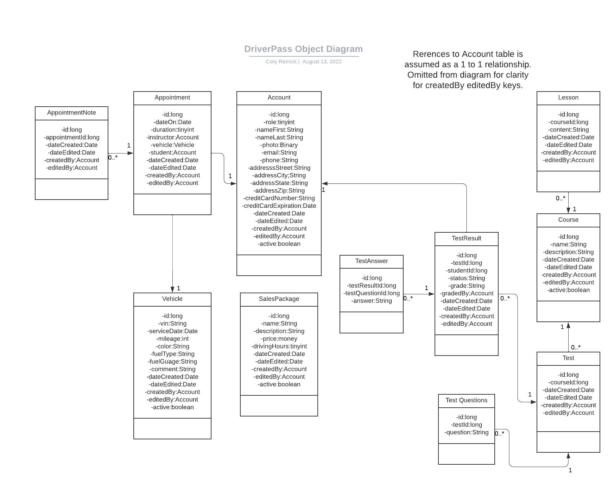

## Technical Requirements

* Server: Unix OS
* Web Server: Apache
* Server DB: MySQL configured for High Availability (commercial costs involved)
* Middle Tier: Java Spring Framework
* Java Platform
* Eclipse Integrated Development Editor
* Jenkins Continuous Integration Continuous Deployment
* Amazon Web Services Cloud Provider
* OWASP Dependency Check, static security analysis